Use Case Descriptions

This use case describes how Jie, the Finance Manager, processes and reimburses employee expenses.

|  |  |  |  |
| --- | --- | --- | --- |
| Use Case Name | Process Employee Expense Reimbursement | | |
| Triggering Event | Jie needed to processes and reimburses employee expenses | | |
| Brief Description | Processes and reimburses employee expenses. | | |
| Actors | Jie (Finance Manager) | | |
| Related Use Cases |  | | |
| Preconditions | Jie is logged into the company's Expense Reimbursement System.  Employee expense report have been submitted and awaiting processing. | | |
| Post Conditions | Employee expense is processed and reimbursed. | | |
| Flow of activities | Actor | | System |
|  |  | Selects the option to process employee expense reports in the Expense Reimbursement System. | Displays a list of all submitted employee expense reports that are awaiting processing. Prompts user to select an expense report to process. |
|  |  | Selects the expense report to process. | Displays the current expense report information, allowing user to review the existing data and prompts to approve. |
|  |  | Views the expenses, approves the expense report for reimbursement. | Records the expense transaction, including detail of the reimbursement made to employee. |
| Exception Conditions | Chooses to cancel Process Employee Expense Reimbursement | | |
|  |  | | |
|  |  | | |

Process Employee Expense Reimbursement Class Diagram

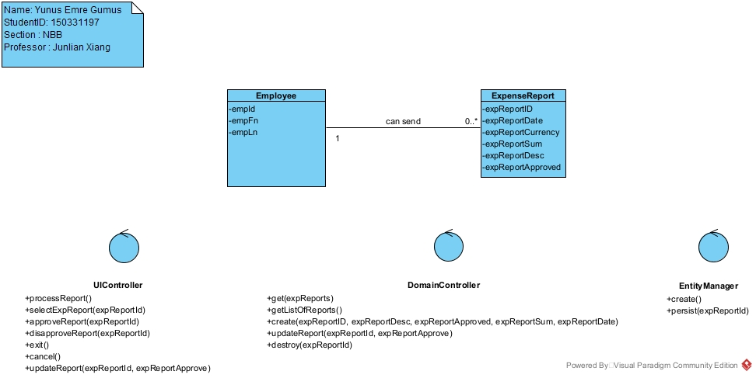

Process Employee Expense Reimbursement Sequence Diagram

